**Data Storytelling 101: Essential Strategies for Data Scientists and AI Practitioners**

**Your days of presenting dry, boring data to your colleagues and clients are over!**

Unlock the power of data storytelling and take your career to new heights! In this post, you’ll learn how to use storytelling with data to engage your audience, make your message stick, and stand out from the competition.

Whether you’re a seasoned pro or just getting started, these techniques will help you transform your data…

*But why should you even care?*

As an AI or data practitioner, your ability to translate technical concepts and data insights into relatable terms is crucial for winning over stakeholders and driving project success.

**You are standing at the intersection of two roads; at the of road #1 are insights and intelligence extracted from data, and road #2 has the project stakeholders, business managers and those who decide your fate(a bit dramatic, but you get the picture).**

To ensure that stakeholders understand the technical requirements, value-add, and impact of data science team efforts, it is necessary for data scientists, data engineers, and machine learning (ML) engineers to communicate effectively. You essentially control traffic flow at the intersection of these two roads.

**This post aims to:**

* Introduce storytelling within the context of data science and machine learning
* Provide tips on how to cultivate storytelling as a skill
* Highlight the benefits of effective storytelling concerning data science
* Provide a framework you can adopt to incorporate storytelling within various scenarios, such as presenting datasets to non-technical stakeholders.

**Storytelling with Data in Action**

Let’s begin by asking:

*What does excellent storytelling entail?*

To understand the power of data storytelling, let’s look at a case study that showcases the key elements of a well-told story using data. By analyzing a real-life example, you’ll better understand what effective data storytelling looks like and how you can use these techniques in your work.

For context, this written piece’s author uses numbers, data, and information to articulate the impact of common global problems and the negative consequences of lack of action. In this case, using data to tell a particular story makes the presented issues real and, simultaneously, the proposed solution both tangible and achievable.

In this written piece, the author uses data to bring global problems to life and make the proposed solutions tangible and achievable. Using numbers, data, and information to illustrate the impact of these issues and the consequences of inaction, the author effectively tells a story that makes the presented issues real and the solution attainable.

**Dissecting a good story told with Data**

As the world’s population continues to grow, particularly in Africa, we see a range of consequences, including economic prosperity, widening income disparities, and uneven wealth distribution. An increase in population size can have various impacts on a nation, country, or continent.

[Ashley Kirk](https://www.linkedin.com/in/ashleyjkirk/), previously a Data Journalist at the Telegraph, addressed what an increase in population size would mean for Africa’s economy in the article, [*What Africa will look like in 100 years*](https://s.telegraph.co.uk/graphics/projects/Africa-in-100-years/index.html).

Ashley uses data and dynamic visualizations to bring the ongoing transformation in Africa to life from the perspective of major cities like Lagos, Dakar, and Cairo. Not only is the storytelling strategically composed to emphasize the fundamental structure of any good data-driven narrative, but it also seamlessly blends together factual information, anecdotes, data, charts, and graphs to create a captivating, informative account of the subject matter.

The opening sections of this article describe the context of the situation and the main point:

*“Can Africa translate its huge population growth into economic development and improved quality of life?”.*

The opening sections provide context and set the stage for the main point, while factual information and key dates, figures, and first-person statements ground the narrative in reality. Charts and graphs help visualize the transformation of Africa’s major cities, highlighting key data points such as population growth, education rates, and life expectancy.

The midsection of the article delves into the conflicts and issues facing these cities, using data, anecdotes, and personal accounts to paint a nuanced picture of the challenges and opportunities at play. Ultimately, this article shows how data practitioners can use data to tell a powerful, humanizing story that resonates with readers.”

Storytelling in data science isn’t just about presenting facts and figures — it’s about creating a relatable and remarkable narrative that connects with your audience. That’s why Ashley’s article includes personal accounts and anecdotes from individuals living in the focus cities, adding a humanizing touch to the data-driven analysis.

Throughout the article, Ashley also incorporates interviews with experts to provide additional context and understanding of how these changes affect people’s lives.

Ashley’s article presents many issues but ends on a high note by discussing solutions that have already been put in place or are being proposed. The presence of institutions taking action to address issues such as education, climate, and conflict, enhances Ashley’s narrative for the reader.

In the next section, we’ll give you a step-by-step framework for crafting your own data-driven story, so you can effectively present your findings to stakeholders in your next presentation, article, or video.

**An effective framework for storytelling in data science**

Storytelling success can be boiled down to three key ingredients: context, narrative, and data. Combining these elements allows you to create a compelling story that resonates with your audience and drives your agenda. Whether you’re telling a factual or fictional tale, these components are essential for crafting a meaningful, data-driven narrative.

Effective data storytelling relies on three key components: **context**, **dispute**, and **solution**. These elements are illustrated in the image below and form the foundation for crafting a compelling story. In this section, we’ll examine these critical components and see how they can be used to enhance your data storytelling skills. When considering these components as base ingredients, it becomes evident how practitioners can combine them with other methods to create a compelling story told with data and enhance their data storytelling skills.

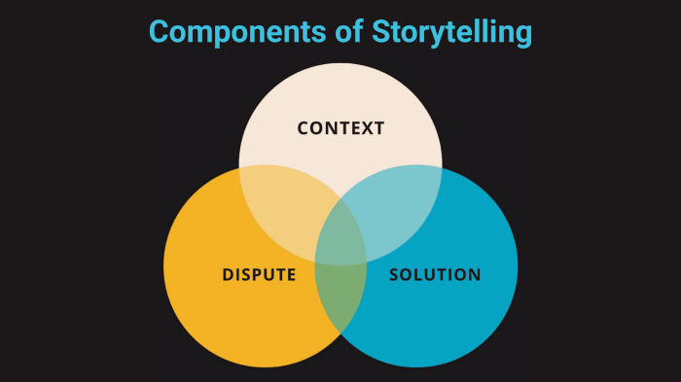

Illustration of the Components of Storytelling: context, dispute and solution — Image by Author

**#1. Context**

The first step in effective data storytelling is setting the context. Without background information, data can be confusing and misleading, leading to project cancellations and business losses.

That’s why it’s so important to provide context for your data — it helps give meaning to the numbers and gives your audience a better understanding of the issue or topic at hand. Remember, data alone isn’t enough to provide actionable insights or meaningful solutions. It’s essential to include other supporting elements to make your data truly meaningful and impactful.

**The context in storytelling is providing information to reinforce, support and reveal the key findings extracted from data samples to provide perspective.** There are many ways to do this, including using actors, anecdotes, visualizations, data labels, diagrams, and more. The goal is to give your audience a better understanding of the context in which your data was collected and how it relates to the bigger picture. By including these reinforcing materials, you can help your audience make sense of your data and see the significance of your findings.

*“305,300 plug-in electric vehicles were sold in the United Kingdom in 2021, representing an approximate 140% year-on-year increase.” —* [*Statista, acea.auto*](https://www.statista.com/statistics/804772/sales-volume-electric-vehicles-eu/)

The material above is intriguing, but what does this data mean in the grand scheme of things? Without context or personal experiences, it can be hard to understand the significance of this figure. That’s where storytelling comes in. By using anecdotes, visualizations, and other supporting materials, we can give our data meaning and help our audience connect with it on a deeper level. Let’s use an actor named James to illustrate the point.

***Author’s Note: Do note that the story below is fabricated and is used to illustrate the point this article is driving.***

*“In February 2020, whilst on his daily commute to work on the M24, James tuned into his morning radio show, UK today. The conversation on the show centered around the rising demonstration of activists against oil companies and drawing public awareness of climate change to the public. One statement stood out to James “the UK produces double the carbon footprint of the world average, that means on an individual basis, we in the UK emit more carbon gas than most people on Earth”.*

*This statement stuck with James, and he decided to take action or at least do his part. James recalled hearing his work colleagues talking about electric vehicles, although James dismissed the conversation due to a lack of interest. But now, James’s interest peaked, and after researching the amount for a deposit required to own a Volkswagen ID.3, he made the conscious decision to purchase one. And so he did. By mid-2021, James owned an electric vehicle. James wasn’t the only one that decided to take action; several million UK residents did. Either by increasing recycling efforts, reducing electric and gas usage or purchasing electric vehicles. The UK’s public awareness of the effect of climate change contributed to the increase in sales of electric vehicles in 2021. Hence, in 2021 the number of electric vehicles sold was over 300,000; this is more than double the amount sold in the previous year. And one of the new electric vehicle owners was James. The UK is now one of the leading countries in regards to the number of electric vehicles sold”*



*“Futuristic depiction of a man charging an electric vehicle” — Image by Author on* [*MidJourney*](https://www.midjourney.com/app/)

The added contextual information uses actors and anecdotes to give the initial data point some life. Charts and diagrams are also key to providing context, as shown in the image below.

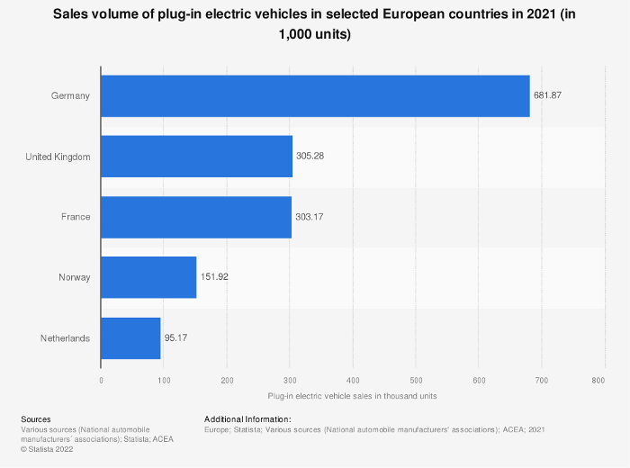

Chart showing the sales volume of plug-in electric vehicles in selected European countries in 2021. Source: [Europe; Statista; Various sources (National automobile manufacturers’ associations); ACEA; 2021](https://www.statista.com/statistics/804772/sales-volume-electric-vehicles-eu/) (CC BY-ND 4.0)

**#2. Dispute**

The dispute in storytelling is the antagonist of your story, and the solution is the hero that rises to the challenge. It’s easier to understand the dispute as the problem, conflict, or issue that needs to be addressed. It’s the driving force behind your story and the reason why your solution is needed. Without a dispute, there’s no need for a solution, and your story falls flat. So, when crafting your data-driven narrative, identify the dispute and how your solution addresses it clearly. This will help you create a compelling, impactful story that resonates with your audience.

Let’s go on to create a dispute to tell a story effectively and, in effect, drive the point of the initial data point:

“*305,300 plug-in electric vehicles were sold in the United Kingdom in 2021, which represents an approximate 140% year-on-year increase.”*

*“The United Kingdom is a net importer of fossil fuels for the use of energy and electricity generation. Fossil fuels power our transportation, electrical and technological services, and even domestic items heavily reliant on fossil fuels’ energy output. The problem is that the UK is determined to significantly reduce its dependence on fossil fuels by 2050. Hence, the question is how the UK can reduce its fossil fuel consumption and move to low-carbon energy sources as an alternative. In addition, fossil fuels are a massive contributor to climate change, contributing to the rise in warmer global temperatures and extreme weather.”*



Futuristic depiction of a world negatively impacted by the effects of fossil fuel utilisation and dependency *— Image by Author on* [*MidJourney*](https://www.midjourney.com/app/)

**#3. Solution**

The solution is the heart of your data-driven story — it’s what your data exists for and the reason behind the context and dispute. In Ashley Kirk’s article, the solution combines initiatives and actions that aim to improve the contributing factors to Africa’s economy. It includes infrastructural development, improved security, modernization, and international aid.

The solution can come in many forms, such as reconfiguring an existing system, implementing new methodologies, and increasing awareness of educational materials.

When it comes to presenting your solution in a data-driven story, it’s important to be direct, obvious, and memorable. Ambiguous solutions can lead to more questions and undermine your confidence and delivery. A clear, actionable solution allows for follow-up steps and helps your plan stand out in a crowded field. It’s time to stop thinking about yourself as an individual and instead consider yourself a company that sells itself and its services via every project completion.

Let’s complete the formulation of our solution based on the initial data point we’re building upon and the dispute our solution will address. Following is a reminder of the initial data point and dispute.

Data point:

*“305,300 plug-in electric vehicles were sold in the United Kingdom in 2021, representing an approximate 140% year-on-year increase.”*

Dispute:

*“The United Kingdom is a net importer of fossil fuels for the use of energy and electricity generation. Fossil fuels power our transportation, electrical and technological services, and even domestic items heavily reliant on fossil fuels’ energy output. The problem is that the UK is determined to reduce its dependence on fossil fuels significantly by 2050. Hence, the question is how the UK can reduce its fossil fuel consumption and move to low-carbon energy sources as an alternative. In addition, fossil fuels are a massive contributor to climate change, contributing to the rise in warmer global temperatures and extreme weather.”*

Below is the proposed solution:

“James’s journey into lowering his carbon footprint began with awareness. Public awareness of the problems caused by the large dependency on fossil fuels and their accompanying damage to our environment is the first step to making the national UK goal of reducing fossil fuel dependency by 2050. To reach more people like James, we propose a scale-up of the WWF Carbon footprint app to include AI-powered functionality that enables services such as energy consumption prediction per household based on historical data and predicted energy demands. This scale-up initiative will require funding of £100 million and will be delivered to the public a year after project approval.”

Again, my proposed solution is fictional and should be used only for illustrative purposes. To be clear, the proposed solution references the story to make it easier to remember. I’ve included information about the project cost and timeline to show that it’s direct. If we wanted, we could easily find flaws in this fictional solution that I put together quickly, but what you should take away from this is the elements that make up a desirable solution: being memorable and straightforward.

“Data storytelling is both an art and a science, and as AI/data practitioners, we can break it down into steps that are easy to follow. As discussed extensively, a compelling data-driven story should include the following components:

1. **Context** — Lay the foundation for your narrative and provide some background.
2. **Dispute** — Discuss the problem associated with the context.
3. **Solution** — Finally, explain and discuss the solution that either ends or mitigates the identified problem.

**Bring the pieces together**

To recap, here’s a framework you can follow when crafting a data-driven story:

1. **Opening Section**: Begin with a factual statement highlighting the dispute's impact or the solution's value. Expand on this with several paragraphs introducing and explaining the context.
2. **Mid Section**: Introduce and expand on the dispute within the context. Use anecdotes, facts, figures, charts, and diagrams to illustrate the problem. Then, introduce and expand on the dispute concerning the solution. Use anecdotes, facts, figures, charts, and diagrams to show the impact and value-added of the proposed solution.
3. **Closing Sections**: Round up by creating a contrast between realities that show the negative consequences of not having a solution and the benefits of having the solution. Include a call to action as a next step that encapsulates the desired outcome of the story told with data.

Combining the key components, elements, and considerations for communicating an effective data-driven story, you’ll end up with the diagram shown below.

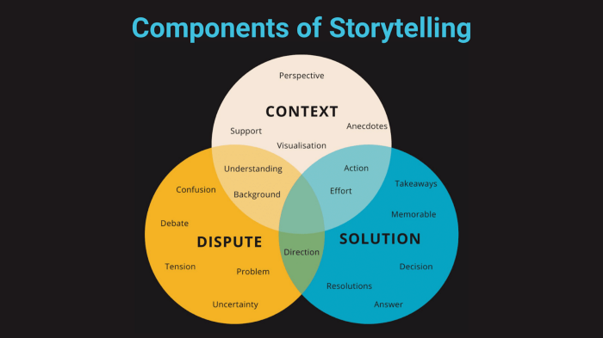

Complete diagram of the components, elements and considerations for storytelling *— Image by Author*

When we provide context alongside dispute and solution, we create a powerful trifecta that helps individuals understand the problem, feel motivated to help solve it, and know how they can take action.

We can create a more informed and engaged public by contextualizing data and supporting critical messages with background information. Whether it’s through anecdotes, visualizations, or data labels, the goal is to provide context that enhances the impact and understanding of your data-driven story.

**Summary**

As companies, societies and essentially, the World become more data-driven, we’ll see an uptrend in demand for AI explainability and data simplification. Practitioners and professionals of all levels within the AI and data industry need to develop data storytelling skills to bridge the gap of understanding in regards to the technicalities of the field, datasets and technologies to non-technical stakeholders, clients and, extensively society.

Your data storytelling journey doesn’t end here. There are many other aspects to cultivating data storytelling skills not covered in this article, such as enhancing data storytelling presentations and pitches by including data visualizations, design considerations, documentation and more. However, the three steps in this article will give you a strong foundation from which you can start to build your data storytelling skills.

The next step is to incorporate the learnings from this article into your next project, practice or organization. I will dive deep into the materials that enhance Data Storytelling presentations in upcoming articles.